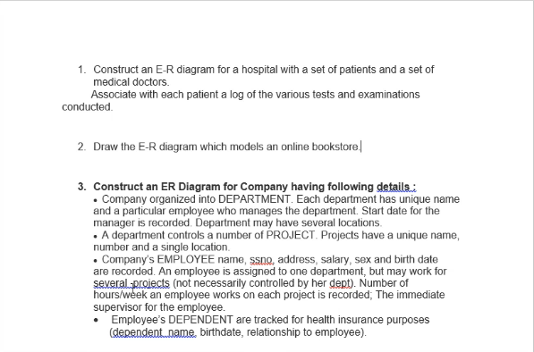

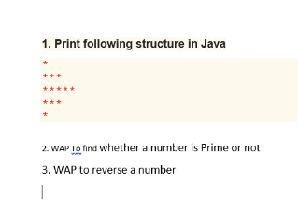

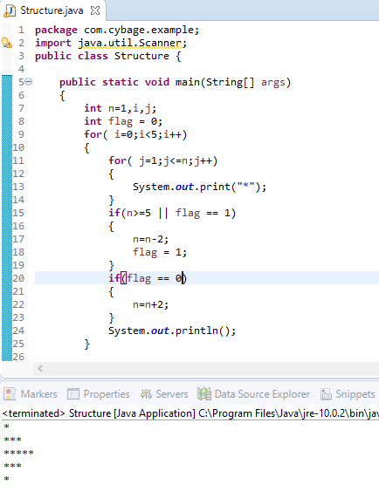

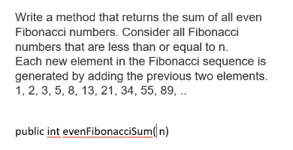

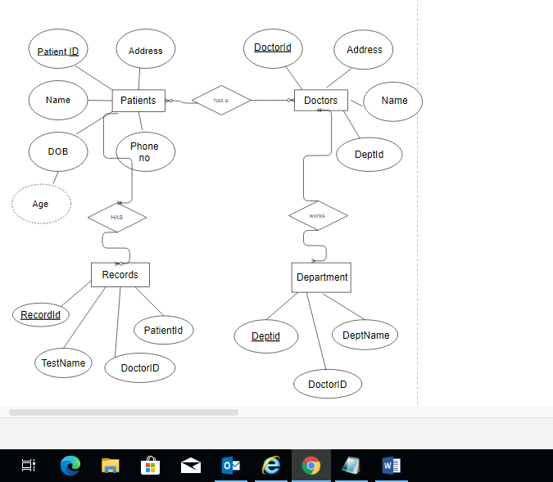

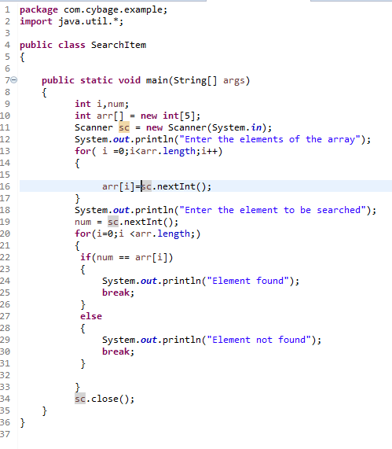

Search in array

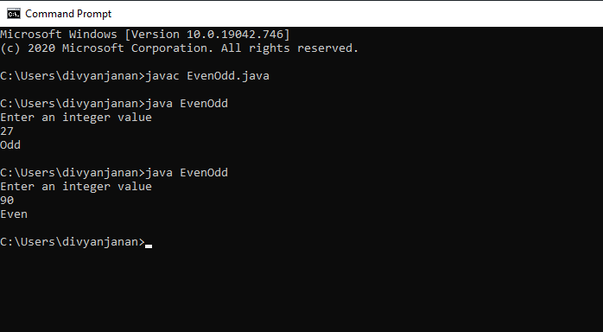

1. Write a program that will accept a 4 digit number(assume that the user enters only 4 digit nos.) and print the sum of all the 4 digits. For ex : If the number passed is 3629, the program should print “The sum of all the digits entered is 20”.

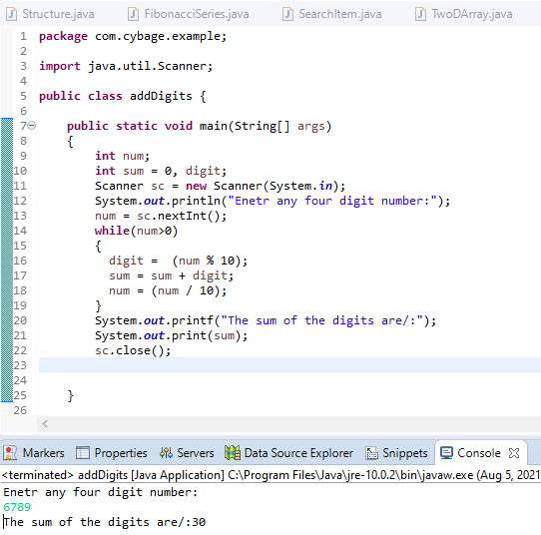

1. Write a program to find greatest number in an array

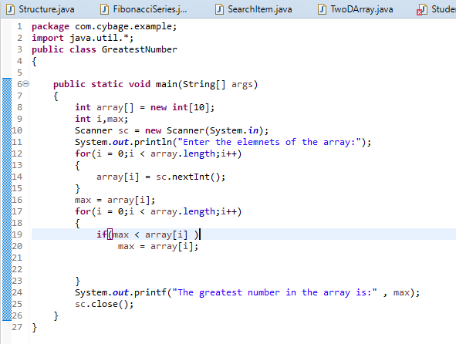

4.Write a program to sort a numeric array element in ascending order.

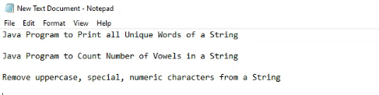

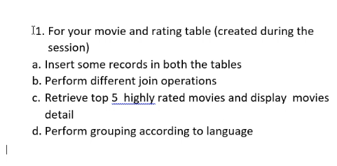

Git pass = 1234

Always use

Git bash commands to push codes into repository

git remote add <provide a new name for the url><repository_url> // to add repository on the code folder

git remote –v //to check if the repository is added or not

git push -u <new repo name> master // to push the code into the repository

git fetch // to show if any branches are created or not

git branch –r // to check all the branches in the remote repository

git clone <url> // to clone the repository

git pull //to update the cloned repository on your own remote systrm

git commands to make a new folder

make a new folder and open git bash in it

git init // to get .git folder

git touch filename.extension // to create a new file into the folder.

vim filename.extension //to open the editor in git bash

save the file

git add filename.extension // to add the file

git commit –m “a message” // to commit the file

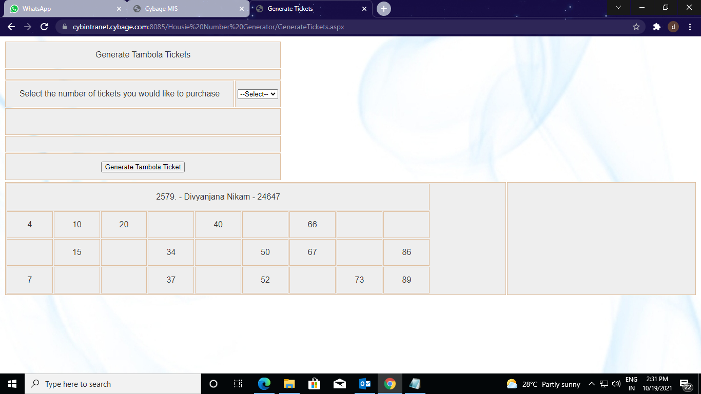

VOWS OF E-MAIL

* Use hello/hi but whatever you are using be consistent.
* Subject must be small and should be to the point
* First alphabet of the subject must be capital.
* No scrolls should be there and if the body has to be long use attachments instead
* Any font except Times New Roman because it only looks good on paper
* Use arial calibiri Tahoma or any sans serif font
* Font Size anywhere between 10 to 12 and be consistent
* No 2 salutations in the mail
* Start the body below h of Hello/Hi after one line break.
* Never use Dear.